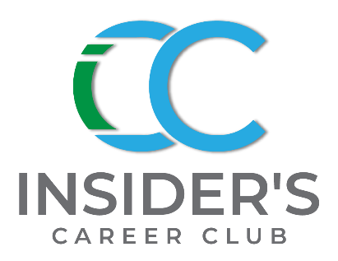
MAY 2021

Hello There! Insiders,
Happy May and Mother’s Day!
We’ve got some great inspiration for you this month in this newsletter.
Need help with a job search? Got a big interview coming up? Sign up for a job-specific Mock Interview. You’ll find job search articles on the Job Search page at www.insiderscareerclub.com.
We can also help you one-on-one with our service offerings. Go to the Career Services section to sign up.

Some Inspiration for you:

Be sure to join us! Here’s what’s on tap:

Upcoming Podcasts Go Live: 6/2 & 6/16/21

Episode #11, Lisa Riley, ODOS FOUNDER with Sindy Thomas

Episode #12, How to work with—Recruiters, Sindy Thomas

Listen on: Apple; Google; Stitcher; Spotify; and more or at: www.insiderscareerclub.com

JOIN US!

BUSINESS NEWS & TRENDS –
MAY 2021

BUSINESS NEWS

Business News – Back to Work!

Forbes Insights - In an article by Richard Sine: questions if employers ready to reopen.
“Forbes in collaboration with Zoom surveyed over 400 senior executives to better understand how leaders are planning for the return
Here are the “Top 5 Changes to Increase Employee Safety: 67% will limit in-person meetings; 60% to modify common areas; 55% reduced access to common areas; 51% automatic doors, voice automation; hands-free fixtures and other techniques to reduce touching surfaces; 48% to wearables to monitor social-distancing.“

Female Voices – Lacking

A Catalyst - survey from 2020 reports Zoom meetings and the lack of normal social cues have contributed to exacerbating an existing lack of female voices in meetings. Denise Woods, Voice & Dialect Coach, recommends we focus on breathing before speaking take a pause.

TRENDS - Workcation

The term “workcation” just thinking about it makes me cringe. I am all in for the sanctity of the “real vacation”. Time off where you shut down and relax. However, in a recent Harris Poll 74% of Americans said they would consider taking a workcation. That’s a shocking number. You should fight for a viable solution to keep some work/life balance. Honoring yourself with a “real vacation” is a way to do that. After all you’re worth it!

ATTENTION NEW GRADS –

The 25 highest paying Internships for 2021 - Glassdoor article dated 4.21.2021

Here are the top 15 listed:
Nvidia avg/mo. $8811
Facebook avg/mo. $8023
LinkedIn avg/mo. $8009
Amazon avg/mo. $7954
Salesforce avg/mo. $7710
Microsoft avg/mo. 7,366
Capital One $7530
Uber avg/mo. $7353
Google avg/mo. $7,129
ExxonMobil avg/mo. $7,018
Apple avg/mo. $$6917
Intuit avg/mo. $6749
BlackRock avg/mo. $6684
AMEX avg/mo. $6622
VMware avg/mo. $6463

Laughter —Best Medicine?

Fortune reports Leaders with a sense of humor are perceived as 27% more motivating and admired. It makes their employees 15% more engaged and twice as likely to solve challenges creatively. This is according to Humor, Seriously. Which also says humor is of benefit to workers and companies.

Predicted—Mass Exodus of Workers

Natalie Baumgartner of LinkedIn is predicting employers are about to have a flood of employee turnover.
The exodus is due to a resulting unhealthy work-life balance due to the pandemic. 40% of workers are working longer hours and 37% are skipping scheduled breaks like lunch which has resulted in them feeling frustrated and burnout. They are also worried their managers think they’re not being as productive when onsite.

In Interviews - Cover This!

When planning your interview questions make sure you have several questions in these areas:
- The position – duties and expectations
- Learn more about the interviewer—how successful have they been?
- Company leadership style—is it open and supportive?
- The company’s missions and company culture
- Delve into how success is measured, what does success look like?
- Learn more about the team you’ll work with, size and personality?
- Ask about opportunities for growth, what does growth look like?

EXTRA, EXTRA! H&M is lending free suits to new grads for their interviews starting May 13, 2021

5.15.21 slt

