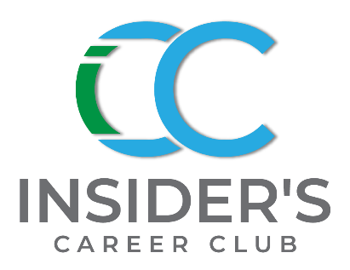
Business News & Trends –
March 2023 Newsletter

Hey Insider Family!
This is our Spring issue and Easter is coming. Get your Easter bonnets and baskets out. The year has been interesting so far with more tech layoffs, threats by the Fed to raise interest rates, 2 bank failures, and maybe a conviction for the 44th President of the US. Fingers and toes crossed! The war in Ukraine still looms on and March Madness thus far seems to be a triumph of the underdogs. Quick question for you are you connected to me on LinkedIn or Facebook? If not, please reach out and connect at: https://www.linkedin.com/in/sindythomas/ or (15) The Insider's Career Club | Facebook

Up next are upcoming is inspiration and career podcasts with two Ladies in honor of women’s history month. We got a dynamic duo for you in April: Dannie DeNovo, The Happiness Coach, Attorney and Author; and Angela Mulrooney, from Unleashing Influence. The podcasts are lively and informative so plan to listen.
Been laid-off? Or planning on making a move but not sure how to do it? Set-up some time with me for a free 20-minute coaching call.
Inspiration is coming up next!

Best!
Sindy, your Career Insider

Inspiration:
” There are no limits to what we can accomplish, except the limits we place on our own thinking.” Brian Tracy
“Believe in yourself and all that you are. Know that there is something inside you that is greater than any obstacle.” - Unknown
““Success is not final, failure is not fatal: It is the courage to continue that counts”. –Winston Churchill
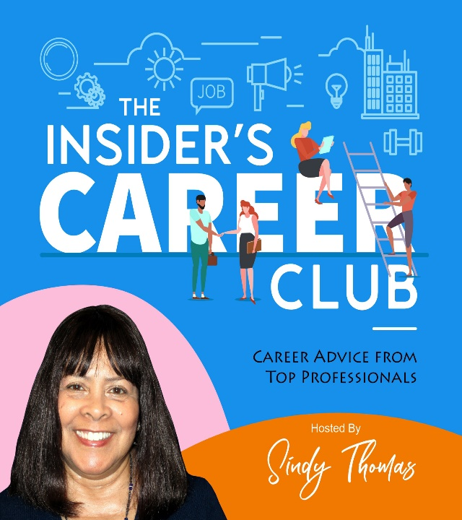

Insider’s Career Club Podcasts – Coming Up!
Insider’s Career Club Podcasts go LIVE on 4/5/23 & 4/19/23 Be sure to join us!

ICC – 3-7, Episode #7, Dannie DeNovo, Happiness Coach, Attorney & Author
Dannie overcame deep depression and learned how to be happy. Hear how she did it. Listen on 4/5 @insiderscareerclub.com or on Apple, Google, Amazon Music, Spotify, IHeartRadio & more.

ICC 3-8, Episode #8, Angela Mulrooney, Unleashing Influence
This podcast shares how Angela suddenly had to pivot to a new career.
Listen: on 4/19 @insiderscareerclub.com or on Apple, Google, Amazon Music, Spotify, IHeartRadio & more.

BUSINESS NEWS & TRENDS –
March 2023

BUSINESS NEWS
Nothing says Spring like Tulips. Get comfortable, put your feet up, and have a cuppa. Here are some of the latest and most interesting news stories.

The NLRB Voids Nondisclosure Agreements
HR Dive reports The National Labor Relations Board doubled down on its stance that employers violate the law when they offer severance packages that require employees to waive certain National Labor Relations Act rights — and has made clear that its position applies retroactively.
The NLRB issued its decision on Feb. 21, holding that severance agreements cannot offer benefits on the condition that workers forfeit a statutory right. In that case, severance benefits hinged on agreeing to a nondisclosure provision that prohibited talent from “making statements that could disparage or harm the image of the employer, its parent and affiliates, and their officers, directors, employees, agents and representatives,” per the board’s memo.
To be clear, the NLRB affirmed that “simply offering employees a severance agreement that requires them to broadly give up their rights under Section 7 of the Act” violates the NLRA. The employer’s offer itself is a move to bar workers from exercising their rights, NLRB asserted.

Bank Fallout
Bloomberg reports Goldman Sachs boosted its estimate of the odds of a US recession to 35% over the next 12 months in response to increased uncertainty over the economic impact of bank stress. The new estimate is still below the 60% median of economists surveyed by Bloomberg. The Federal Reserve’s emergency loan program may inject as much as $2 trillion of funds into the US banking system and ease the liquidity crunch, according to JPMorgan.

Clean Slate Laws
Have you heard of Clean Slate Laws being put into effect across the country? Some states that have passed these laws include Connecticut, California, Colorado, and Michigan to name a few.
California’s law will go into effect July 2023. In an TLNT article by Peter Crush he notes “Clean slate laws are a model aimed at providing relief to those with criminal records – enabling their former criminal history to either be expunged or sealed. The goal is to remove barriers to employment.”
The pluses of the California’s law will allow for criminal records of past offenders to be undisclosed on a background check. If the former offender has remained “clean” for a prescribed number of years, they have the right to appeal to the Court for their record to be sealed or expunged. This means a potential employer’s background check will not show their past offenses. These erased crimes are mostly for misdemeanors. Felonies will not be erased. However, there are exceptions for these laws. One exception is for those with past sexual behavior offenses. These laws do not cover them, and these records will surface on a background check.
The laws are designed to give applicants with prior records a chance to have a level playing field. It will also help prior offenders by giving them an opportunity to have a better quality of life for themselves, their families and provide them with a chance at rising out of the poverty level. Per TLNT “…. researchers at the Brennan Center for Justice, in New York have found that formerly incarcerated Americans typically see their subsequent earnings

reduced by an average of 52%. This compares to studies that have proved that if criminal records are wiped clean, former criminals were 11% more likely to have a job and were earning 25% more.”
The minus is the law does give me pause, especially for employers who are trying to create safe work environments. The level of safety provided now may fall by the wayside. Will these new laws cause workers hired before clean slate laws went into existence to look at new hires with suspicion? Will workers feel safe at work? Will employers employ more security guards or other forms of monitoring onsite?
No one knows how these laws will impact the workplace. But I wonder if workers will be able to have the same kind of peace of mind they had before. Let us keep watch and see what happens.

GOOD NEWS
From HR Dive:
After reporting success with its Returnship Program in select cities, PepsiCo Beverages, North America will expand the offering to include 12 to 15 positions in supply chain, sales and commercial fields — more than double the number of positions available in 2022, the company announced Jan. 10.
The program provides returners professional development, networking, and mentor support. Successful participants may also receive a full-time job offer upon completion; 80% of program participants in 2022 accepted such an offer, the announcement said.
In recent years, returnships have emerged as one way to bring caregivers — especially women who take time off to care for children — back into the workforce. PepsiCo’s program specifically targets women with at least five years of work experience who have taken at least two years off for caregiving.
Various companies, including Amazon, IBM, Microsoft and Schneider Electric, offer some form of returnship, many of them specifically targeting women. Many women were driven out of the workforce during the pandemic amid the closure of day cares and schools, putting immense pressure on caregivers to stay at home.
Microsoft began implementing unlimited paid time off for salaried employees in the U.S. on Monday, a company spokesperson confirmed in an email to HR Dive.
According to an internal memo obtained by The Verge, Microsoft will still offer 10 corporate holidays alongside the unlimited PTO — termed “Discretionary Time Off,” or DTO — as well as leaves of absence; sick and mental health time off; jury duty time off; and bereavement leave. Employees with unused vacation balances from the company’s previous framework will receive a payout in April 2023, The Verge reported.

THE ECONOMY & JOBS

Hybrid Work Here to Stay
Hybrid work appears here to stay, and employers are coming up with a whole new class of catchphrases to promote their flexible-work options. At KPMG, it’s “Flex with Purpose,” while “Amex Flex” plays off that company’s well-known brand. GM tells staff to “Work Appropriately.” Others have loftier aspirations, like the “New Era of Agility” from Stellantis or Accenture’s “Omni-connected.” They’re all illustrative of the ways companies see the plans shaking out—and how hard it is to get them right.

Job Cuts
Bloomberg reports Despite growing belief in that “soft landing,” Silicon Valley CEOs are taking no chances and instead firing their workers by the tens of thousands. Google joined the crowd as its parent company Alphabet terminated 12,000 people, or more than 6% of its global workforce, becoming the latest tech giant to retrench after years of abundant growth. In the wave of tech worker culling, some 100,000 people have lost their jobs so far.

Mass firings by Amazon and Microsoft are the latest blow for the Seattle region, which is still struggling to recover from the pandemic’s decimation of its commuter economy—one that, as in many cities, is the lifeblood of America’s second-largest tech hub. The number of jobs lost, at least 28,000 globally between the two companies, is a psychological blow that may have long-lasting effects.

Disney and Amazon have also revealed they are both reducing their headcount by significant numbers---in addition to previous cuts. There was a request by 1400 Google employees for layoffs to be managed with more compassion and pleading that lay-offs not be done via Zoom. The workers want to be able to say a proper good-bye to their colleagues.
This is inline with what HR Dive has reported on how workers feel about layoffs. The data:
- More than 8 in 10 employees of the nearly 1,400 surveyed by Eagle Hill Consulting said layoffs via emails are wrong. Instead, 72% said they prefer an in-person meeting.
- Close to 60% of the workers surveyed said they were told about layoffs in person, although 16% said it was in a group setting. Of the 42% who were told virtually, a quarter were informed by phone or by email.

February Unemployment Rate
The BLS.gov reports in February, unemployment rates were lower in 9 states, higher in 3 states and the District of Columbia, and stable in 38 states. Nonfarm payroll employment increased in 6 states and was essentially unchanged in 44 states and the District. The unemployment rate increased slightly to 3.6 percent.

The Insider’s Career Club - Career Services 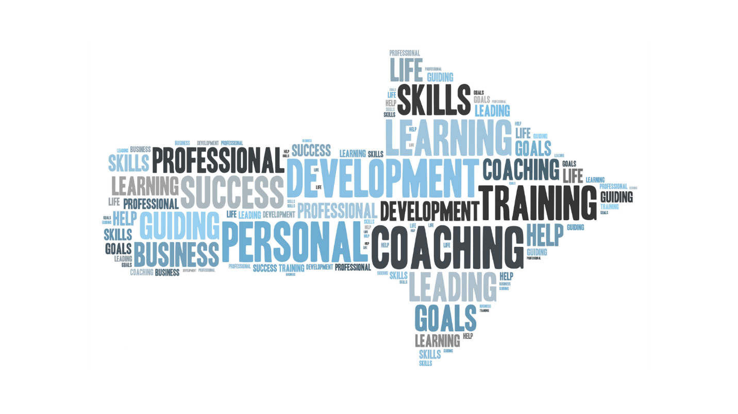

Career Coaching:

Great careers do not just happen--they are planned! Book a free 20-minute Discovery call now!

Impacted by a big lay-off? Unsure how to pivot to a new industry? Maybe you have a big interview coming up?
If you are considering a career pivot a Career Exploration Session, is for you. I’ll help guide you to a path that’s right for you.
Increase your chances to progress to the next interview. A Mock Interview Coaching Session helps to hone your interviewing skills so you can shine. Sign-up today!
Services:
- Resume Review
- Mock Interviewing
- Career Coaching

Sign up for a call with Sindy on the Career Services page at: www.insiderscareerclub.com

